Assignment 3

Part II

1. Atomicity

Screenshots:

(1) Run Atomic Counter with Atomic Integer
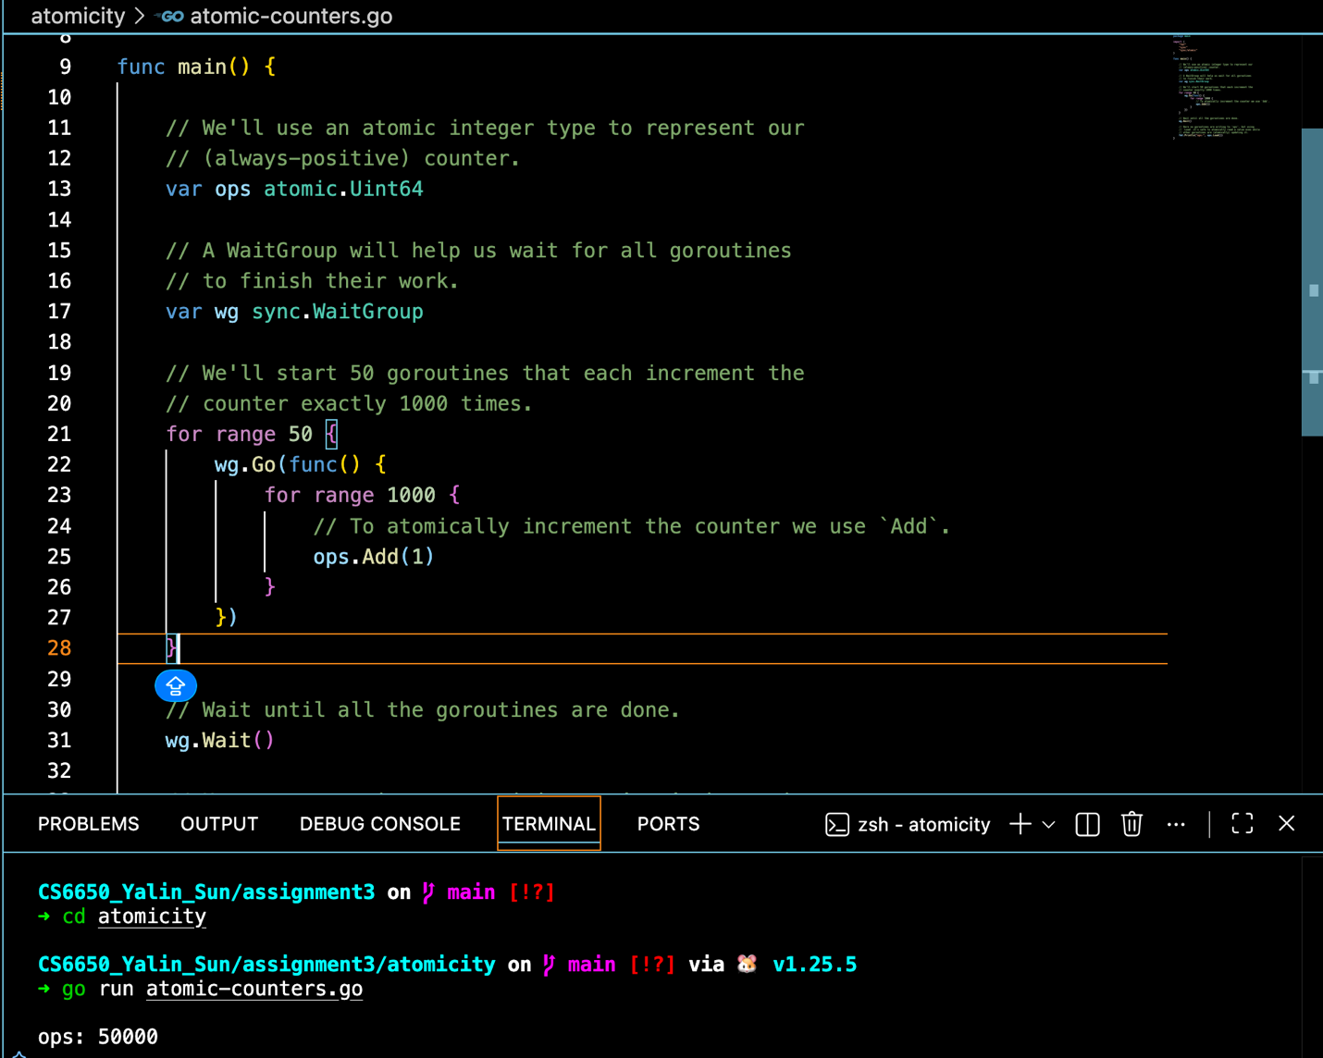

(1) Run Atomic Counter with Regular Integer
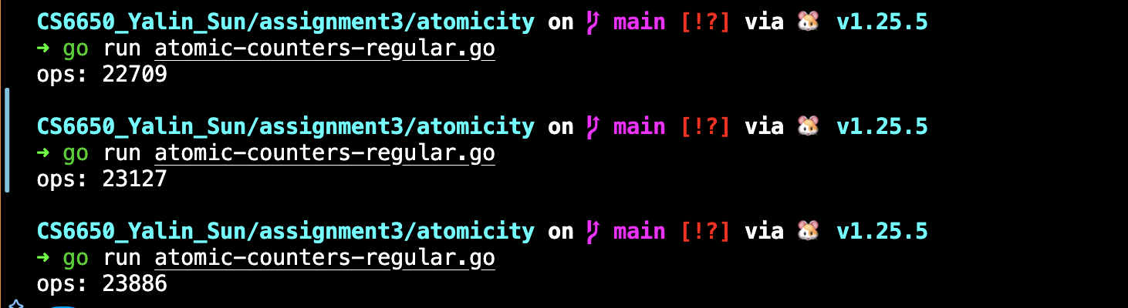

(3) Run with -race flag
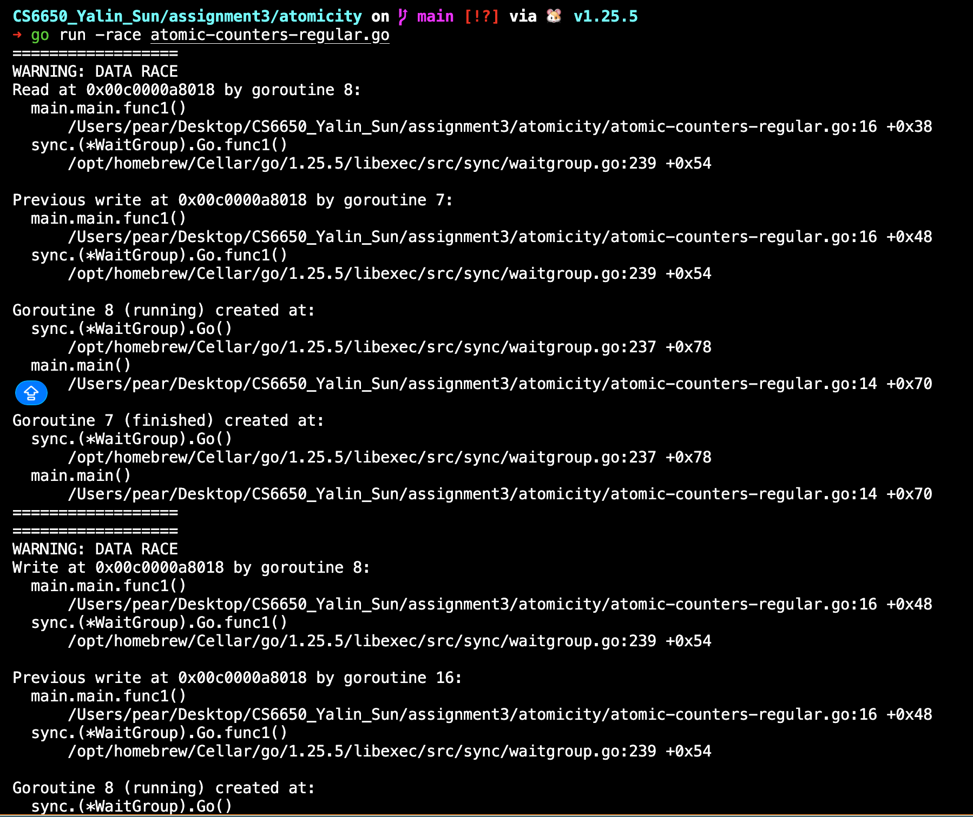
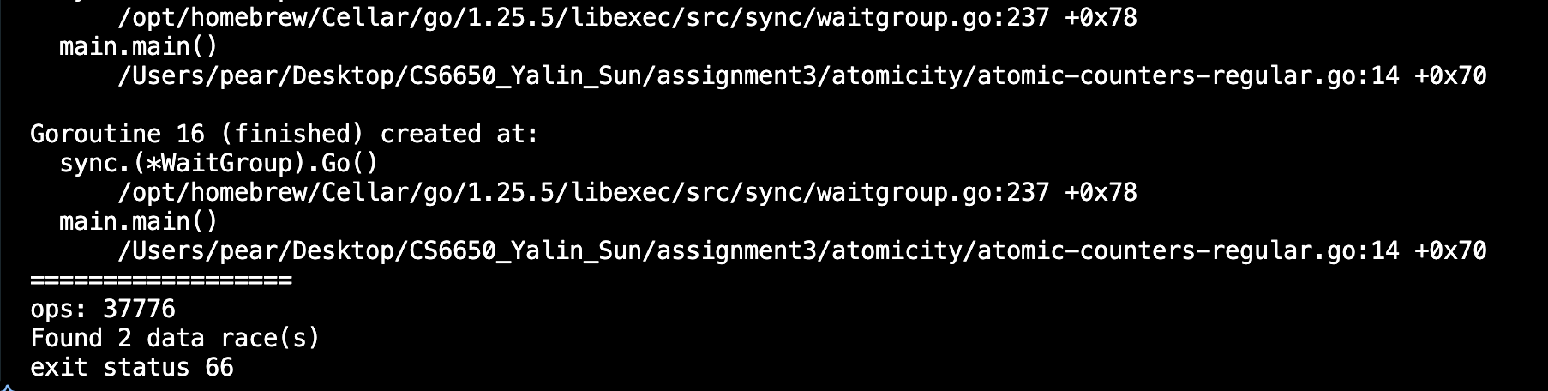
Q1: What Values do you see?

In the atomic version, the value of ops is stable and consistently reaches 50000.

In the regular ops++ version, the value of ops is often smaller than 50000 and varies across different runs, producing non-deterministic results.

Q2: What is happending?

The operation ops++ is not atomic. Internally, it consists of three steps: read, modify, and write. When multiple goroutines execute this operation concurrently without synchronization, race conditions occur. Specifically, multiple goroutines may read the same value before any of them writes back the updated result, which leads to lost updates.

As a result, some increments are overwritten, causing the final count to be smaller than expected and unstable across runs.

Q3: Try running with the -rage flag, what does that do?

Running the program with the -race flag enables Go’s data race detector.

It instruments the program at runtime to monitor concurrent memory accesses. When it detects unsynchronized concurrent reads and writes to a shared variable, it reports a DATA RACE warning, along with the relevant code locations and stack traces.

The race detector can only identify race conditions that occur along execution paths that are actually exercised at runtime, so it does not guarantee detection of all possible races.

Description of Concepts I’ve Learned

(1) Atomic Operations
Atomic operations ensure that updates to shared variables are performed as a single, indivisible step. In the atomic version of the experiment, the counter consistently reached the expected value of 50000, providing evidence that atomic increments prevent interference between concurrent goroutines and guarantee correct results.

(2) Race Conditions and Lost Updates
When using a regular ops++ operation, the program produced non-deterministic and smaller results. This occurs because ops++ is a read–modify–write operation and is not atomic. When multiple goroutines execute this operation concurrently, some updates are lost, leading to incorrect final counts. The varying results across multiple runs provide clear evidence of this race condition.

(3) Data Race Detection
Running the program with Go’s -race flag enabled the runtime data race detector. The detector reported concurrent unsynchronized accesses to the shared variable and identified the relevant code locations. This confirmed that the incorrect results in the non-atomic version were caused by data races during execution.

2. Collections

Screenshot

(1) Run the code first time
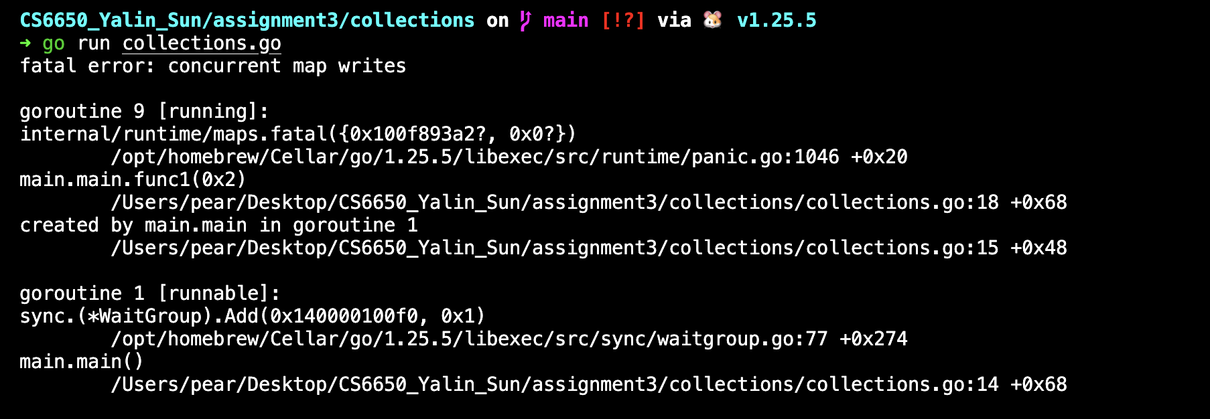

(2) Run the code second time
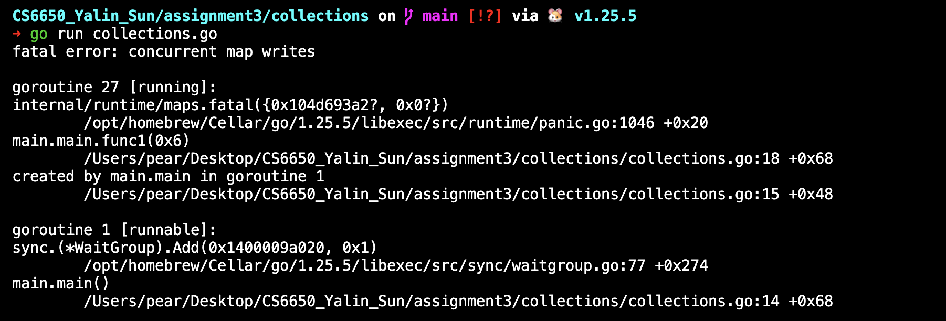

(3) Run the code third time
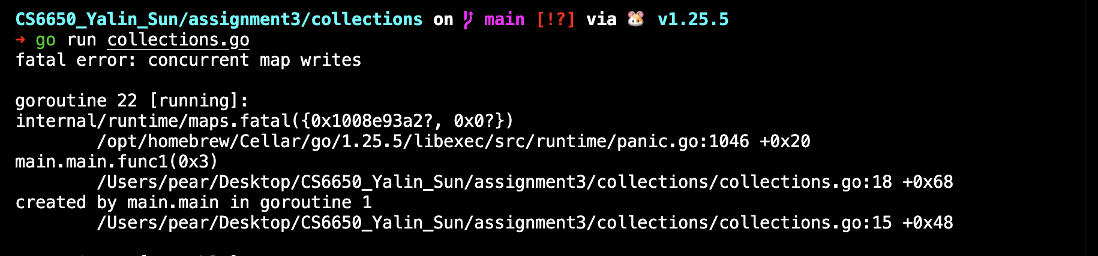

Result:

Since the program consistently crashes before producing len(m), there are no numeric results to average; therefore the mean is not applicable for the plain map concurrent-write case.

You might see that your program crashed. Why? What's going on?
When the program crashes with fatal error: concurrent map writes, it is because Go’s built-in map type is not safe for concurrent writes. Even though each goroutine writes to a distinct key range, all goroutines are still modifying the same shared map data structure at the same time.
A map update is not a simple, atomic action internally. The map may need to update shared metadata (such as buckets, hash table state, or resizing/rehashing information). If multiple goroutines write simultaneously, they can corrupt the map’s internal state. To prevent silent memory corruption and incorrect behavior, the Go runtime includes a safety check and will panic when it detects concurrent writes to a map. In short: the crash happens because multiple goroutines are writing to the same map without synchronization, which causes a data race and can break the map’s internal invariants.
Description of Concepts I’ve Learned
Concurrent Access to Maps
This experiment demonstrates that Go’s built-in map type is not safe for concurrent writes. When multiple goroutines write to the same map without synchronization, the program may crash due to corruption of the map’s internal data structures.
The evidence for this behavior is that running the program multiple times consistently results in a runtime panic with the message fatal error: concurrent map writes, often before the program can print the final map size. Even though each goroutine writes to a distinct set of keys, the shared map metadata is still modified concurrently. This confirms that synchronization is required when accessing maps concurrently in Go.

3. Mutex
(1) Run the code for three times
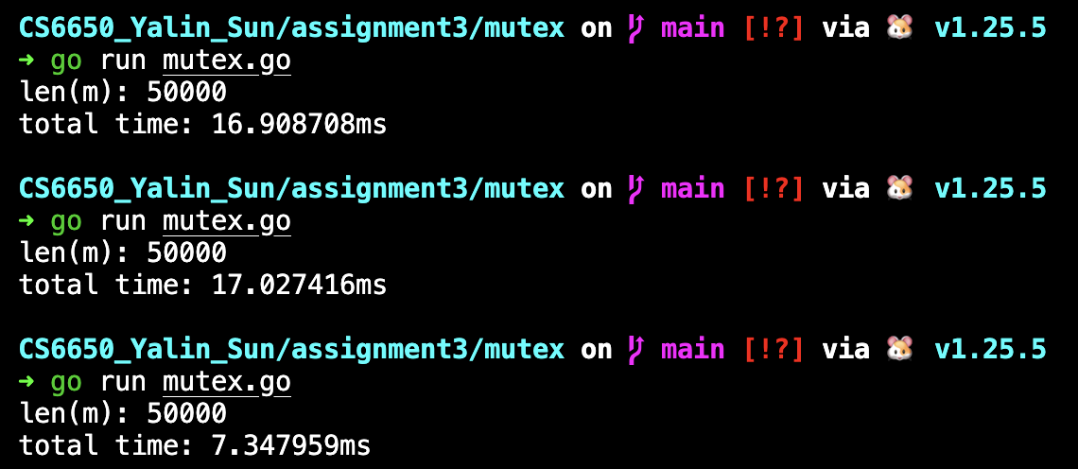
What's the lesson learned here?
The key lesson learned is that mutexes provide correctness and safety for concurrent access to shared data structures, but at a performance cost. By protecting the map with a mutex, concurrent writes no longer cause crashes or data races, and the final map size is consistently correct. However, because every read and write must acquire the same lock, goroutines contend for the mutex, which serializes access and increases total execution time. This highlights the fundamental tradeoff in concurrent programming between correctness and performance, and shows that synchronization mechanisms must be chosen carefully based on the workload and access patterns.
Description of Concepts I’ve Learned
Mutual Exclusion
A mutex enforces mutual exclusion, ensuring that only one goroutine can access the shared map at a time. After wrapping the map with a mutex, the program no longer crashes and consistently produces the correct result, demonstrating that mutual exclusion prevents unsafe concurrent access.
Data Race Prevention
By locking before every read and write operation, the mutex eliminates data races on the shared map. The absence of runtime panics and the stable map size of 50000 across repeated runs provide evidence that race conditions are successfully prevented.
Lock Contention and Performance Tradeoff
Although the mutex guarantees correctness, it introduces lock contention because all goroutines must acquire the same lock before accessing the map. The measured total execution time shows that operations become partially serialized, illustrating the tradeoff between correctness and performance when using mutex-based synchronization.

4.RWMutex
Screenshot
(1) Run five times
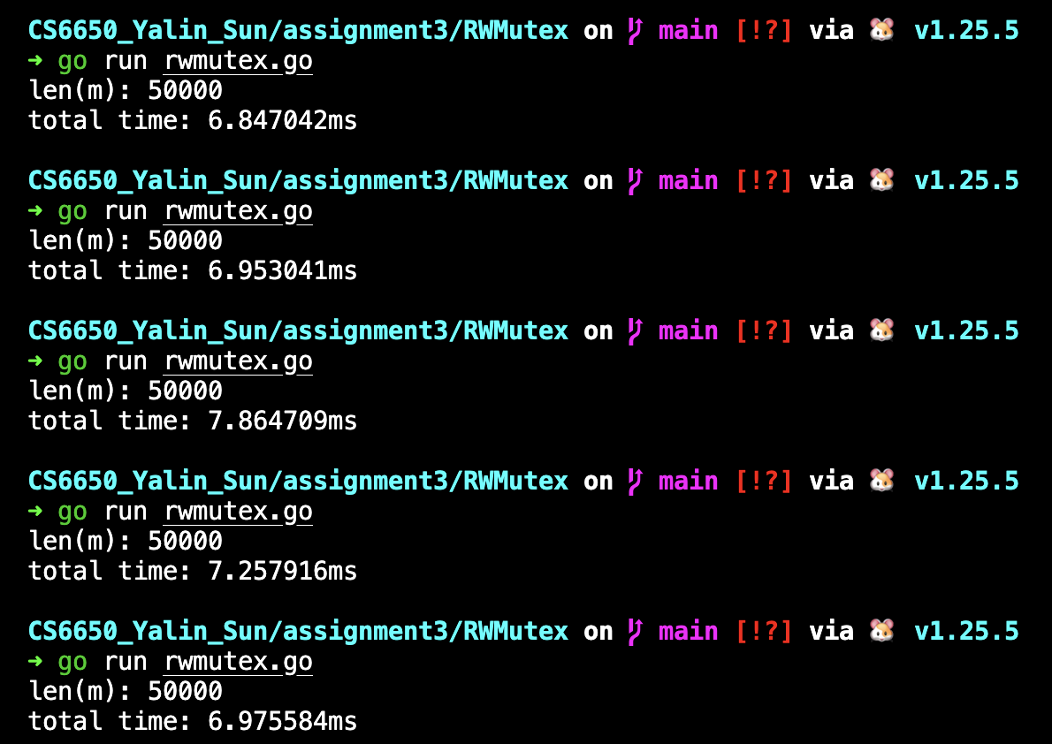
Did this change anything? Why or why not? What is the lesson learned here?
After replacing Mutex with RWMutex, the program consistently produces the correct result with len(m) = 50000. Across five runs, the total execution time ranges from approximately 6.8 ms to 7.9 ms, with a mean execution time of about 7.18 ms.
This change does not significantly improve performance compared to using a regular mutex. The reason is that this workload is write-dominated, and write operations still require an exclusive lock (Lock) even when using RWMutex. As a result, concurrent writes are serialized, and the main benefit of RWMutex—allowing multiple concurrent readers—is not utilized.
The lesson learned is that RWMutex is most effective in read-heavy workloads, where many goroutines perform reads and few perform writes. In write-heavy scenarios like this one, RWMutex provides correctness but offers little or no performance advantage over a regular mutex, and may even introduce slight overhead due to its more complex locking mechanism.
5. Sync.Map
Screenshot
(1) run three time
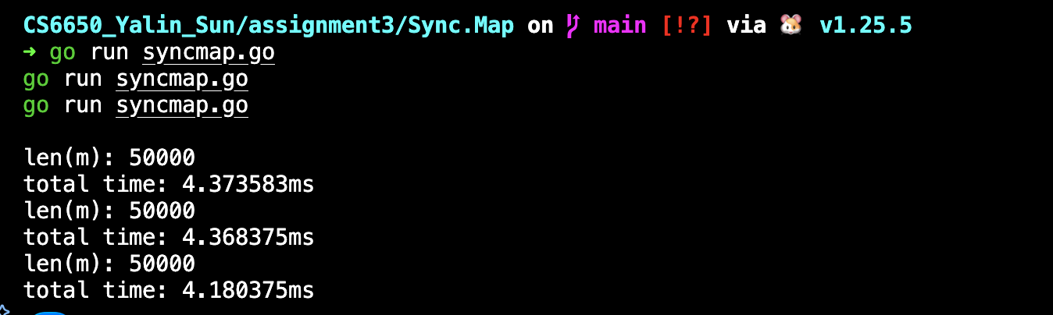
Lesson Learned
The main lesson learned from this experiment is that the performance of concurrent data structures strongly depends on the access pattern, especially the ratio of reads to writes. While all synchronization approaches (Mutex, RWMutex, and sync.Map) ensure correctness and prevent crashes, they differ significantly in performance due to how they manage contention. There is no single “best” solution for all cases—choosing the appropriate approach requires understanding the workload characteristics.
Quantitative Comparison of Results
Approach | Mean Time (ms) | Correctness | Notes
map + Mutex | 13.76 ms | Correct | High lock contention
map + RWMutex | 7.18 ms | Correct | Writes still exclusive
sync.Map | 4.31 ms | Correct | Best scalability here
From these results:
sync.Map is approximately 3× faster than Mutex and approximately 1.7× faster than RWMutex.
Explanation of the Results
Mutex
Using a regular Mutex results in the slowest performance because all goroutines must acquire the same exclusive lock, even for independent writes. This causes heavy lock contention and serializes access to the map, leading to longer execution time and higher variance.
RWMutex
RWMutex improves performance compared to Mutex, but the improvement is limited in this experiment. Although RWMutex allows multiple concurrent readers, write operations still require an exclusive lock. Since this workload is mostly write-dominated (50,000 writes), the advantage of concurrent reads is largely unused.
sync.Map
sync.Map achieves the best performance in this experiment. It is internally optimized for concurrent access and avoids a single global lock, allowing better scalability when many goroutines access the map simultaneously. In this write-heavy but highly parallel workload with distinct keys, these optimizations significantly reduce contention.
What Happens if Read Operations Dominate?
If the workload becomes read-heavy, the relative performance of these approaches would likely change:
Mutex: Still the worst option, since all reads and writes must be serialized.
RWMutex: Performance would improve significantly, as multiple goroutines can hold read locks (RLock) concurrently.
sync.Map: Often performs best in read-dominated or cache-like scenarios, especially when keys are stable and reads greatly outnumber writes.
Thus, RWMutex and sync.Map are better suited for read-heavy workloads, while a regular Mutex is generally only appropriate for simple or low-contention cases.
Final Tradeoff Summary
Mutex
Simple and easy to reason about
Poor scalability under contention
RWMutex
Better performance for read-heavy workloads
Limited benefit when writes dominate
sync.Map
Best performance in this experiment
More complex semantics and less type-safe

6. File Access
Screenshot
(1) run the code for 3 times
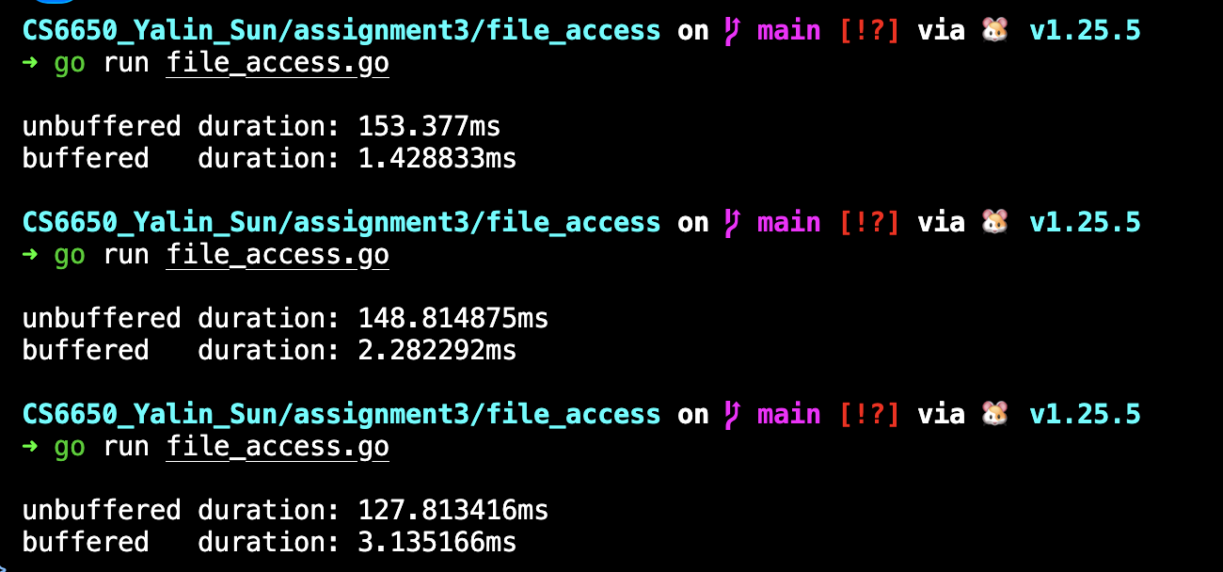
Experimental Results (Quantitative Comparison)
In this experiment, I compared writing to a file using unbuffered I/O versus buffered I/O (bufio.Writer). Each method wrote 100,000 lines to a file.
Based on three runs, the observed execution times were:
Mode | Run 1 (ms) | Run 2 (ms) | Run 3 (ms) | Mean (ms)
Unbuffered | 153.38 | 148.81 | 127.81 | 143.34
Buffered | 1.43 | 2.28 | 3.14 | 2.28
Buffered I/O is approximately 60× faster than unbuffered I/O in this experiment.
What Is Going On? Why Is Buffered So Much Faster?
The performance difference is caused by the number of write operations and system calls.
In unbuffered mode, each loop iteration calls f.Write(...), resulting in 100,000 small write operations. Each write incurs significant overhead from function calls, system calls, and kernel boundary transitions.
In buffered mode, writes are first accumulated in a user-space buffer. Many small writes are coalesced into fewer large writes, dramatically reducing the number of system calls.
Although the operating system still uses its own page cache in both cases, user-space buffering significantly reduces syscall overhead, which dominates performance in the unbuffered case.
Lesson Learned
The key lesson learned is that buffering greatly improves I/O throughput by batching small writes into larger ones. Writing data incrementally without buffering is extremely inefficient due to repeated system call overhead. Using bufio.Writer provides a large performance improvement with minimal complexity.
Tradeoffs Between Unbuffered and Buffered I/O
1) Performance vs. Latency
Buffered I/O achieves much higher throughput but delays when data is actually written to the underlying file until the buffer is flushed.
Unbuffered I/O makes data available to the kernel immediately, but at a very high performance cost.
2) Performance vs. Durability
Calling Flush() only moves data from user space to the kernel; it does not guarantee persistence to disk.
Strong durability requires fsync, which significantly reduces performance.
This highlights the tradeoff between throughput and durability guarantees.
3) Simplicity vs. Efficiency
Unbuffered I/O is simpler but inefficient.
Buffered I/O requires managing buffers and flushing, but provides massive performance benefits.

7. Context Switch
Screenshot
(1) Run 3 times
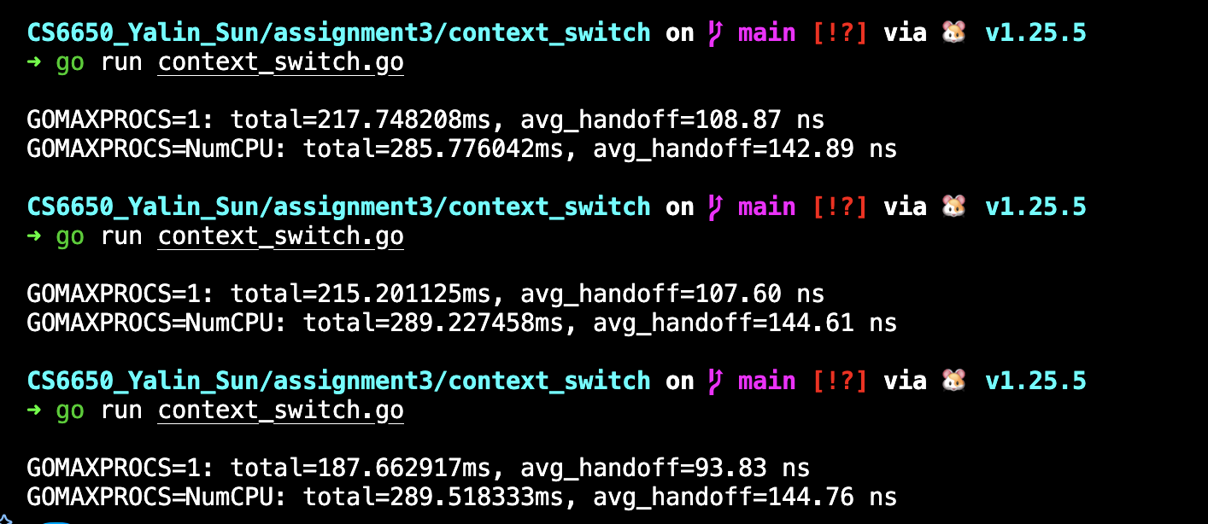
Experimental Setup
In this experiment, two goroutines repeatedly passed an empty signal back and forth over an unbuffered channel for 1,000,000 iterations. The total execution time was measured and divided by twice the number of round trips to compute the average goroutine handoff (switch) time.
The experiment was conducted under two configurations:
GOMAXPROCS = 1 (single OS thread)
GOMAXPROCS = NumCPU (multiple OS threads)

Quantitative Results
Based on three runs, the observed average handoff times were:
Configuration | Avg Handoff Time (ns) | Faster?
GOMAXPROCS = 1 | ~103 ns | yes
GOMAXPROCS = NumCPU | ~144 ns | no
Across all runs, the single-thread configuration consistently achieved a lower average handoff time than the multi-threaded configuration.
Which One Is Faster and Why?
The experiment shows that using a single OS thread (GOMAXPROCS = 1) is faster for this workload.
This happens because the ping-pong pattern involves tight, synchronous coordination between two goroutines. When both goroutines are scheduled on the same OS thread, the Go runtime can switch between them with minimal overhead. The handoff remains entirely within user space and avoids cross-thread coordination.
When multiple OS threads are available, goroutines may be scheduled on different threads. Although this allows parallelism in general, it introduces additional overhead in this specific case:
1) Thread wake-ups and coordination
2) Cache coherence and memory synchronization costs
3) Extra runtime scheduling overhead
Because the workload is inherently sequential (each send must wait for a receive), parallelism does not provide any benefit and instead increases the cost per handoff.
Relation to Process, Container, and VM Context Switching
This experiment also helps illustrate how different levels of context switching compare:
1) Goroutine switching is lightweight and mostly handled in user space by the Go runtime.
2) Process context switching involves kernel scheduling, register state changes, and address space management, making it significantly more expensive.
3) Containers are essentially processes with isolation, so their context switching cost is similar to processes.
4) Virtual machines add an additional layer of virtualization, typically making context switching even more expensive.
Thus, the measured goroutine handoff time (on the order of ~100 ns) is orders of magnitude smaller than context switching costs at the process, container, or VM level.
Part III
1. Locust
Screenshot
(1) Start Go Server
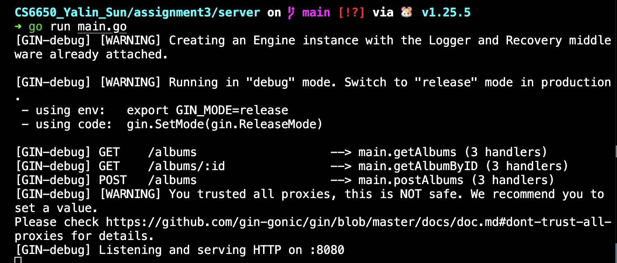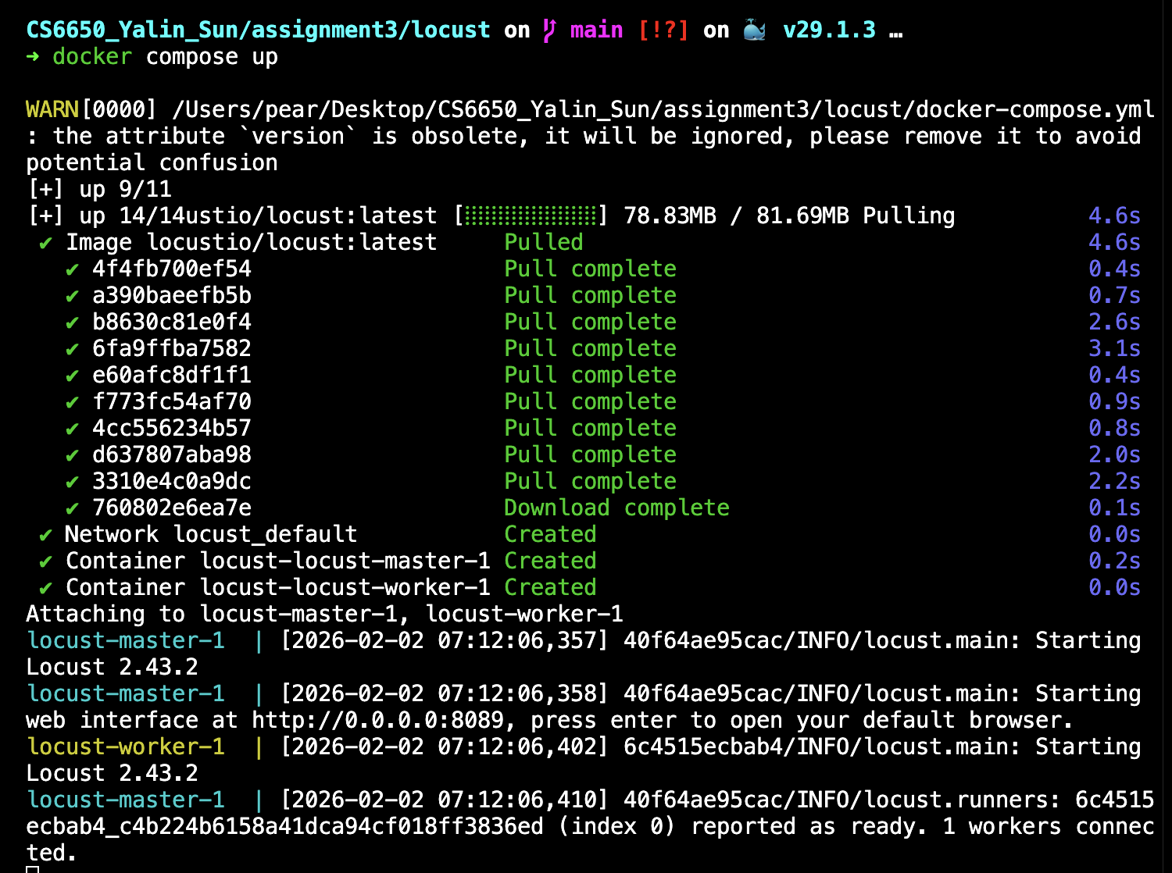
(2) Locust Statistic and Charts
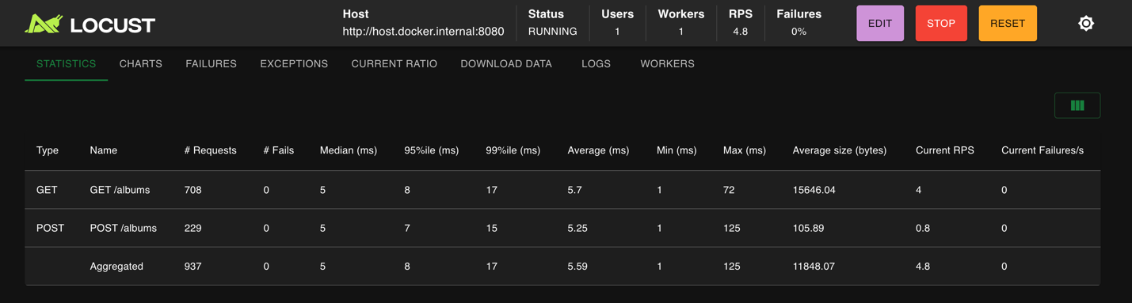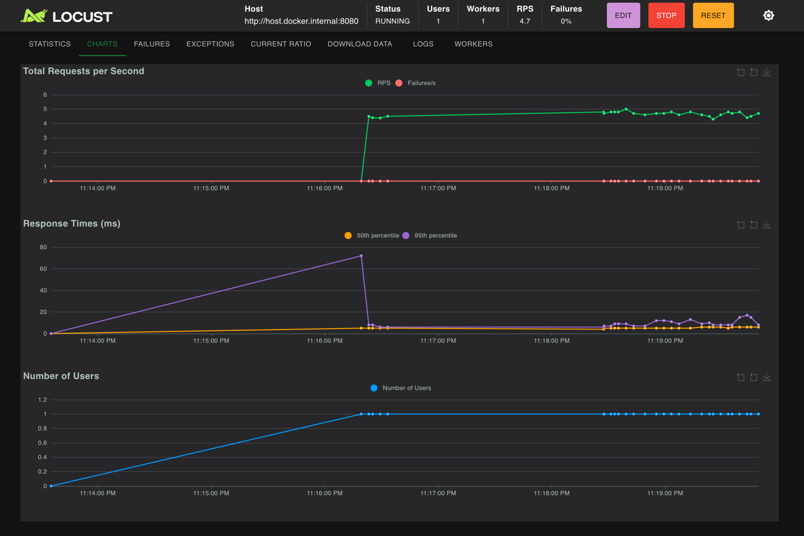
(3) Set GET=1 POST=0
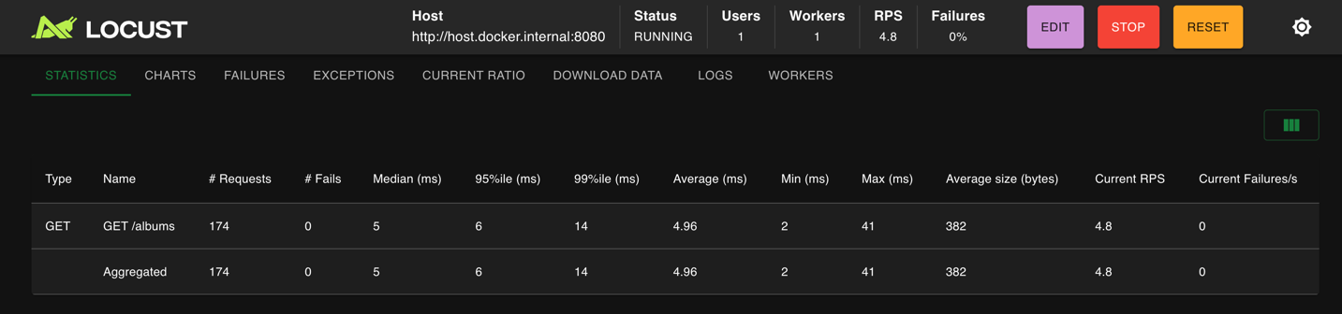
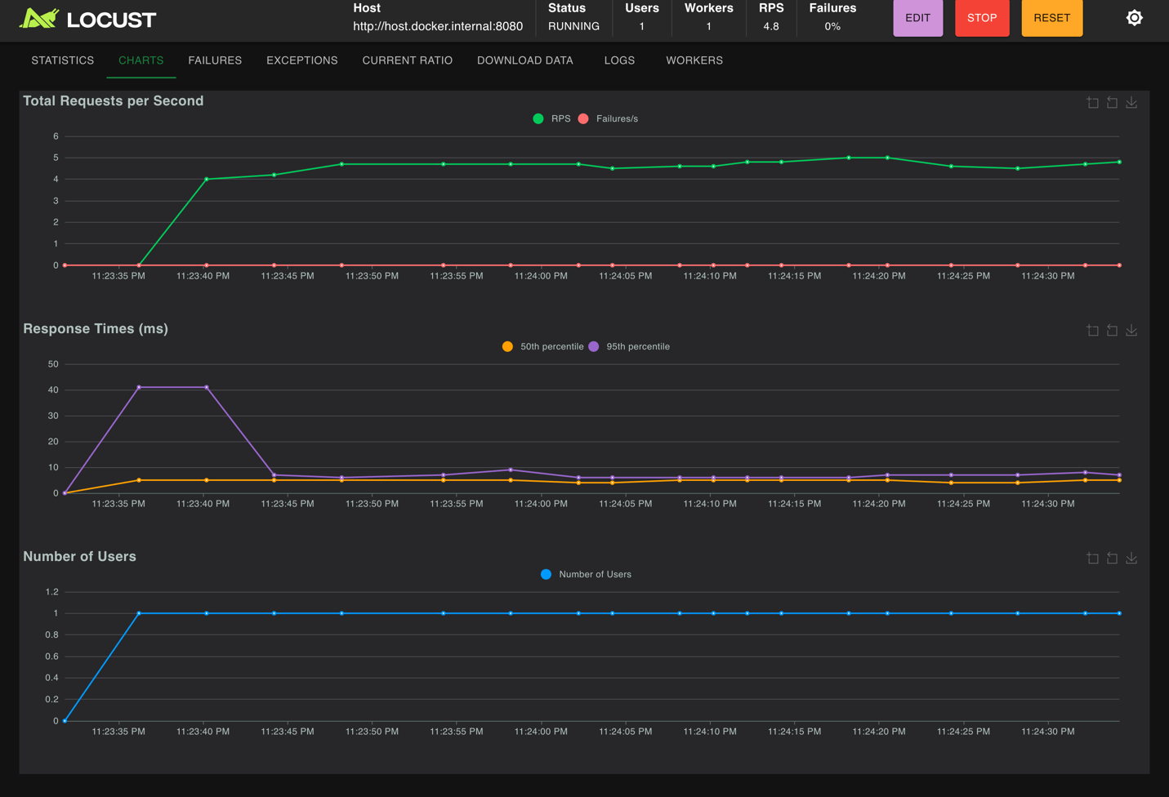
(4) Set GET=0 POST=1
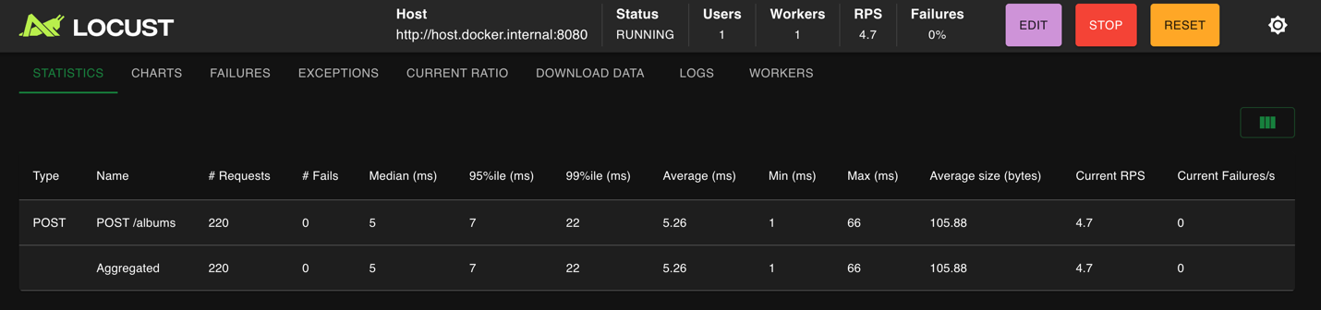
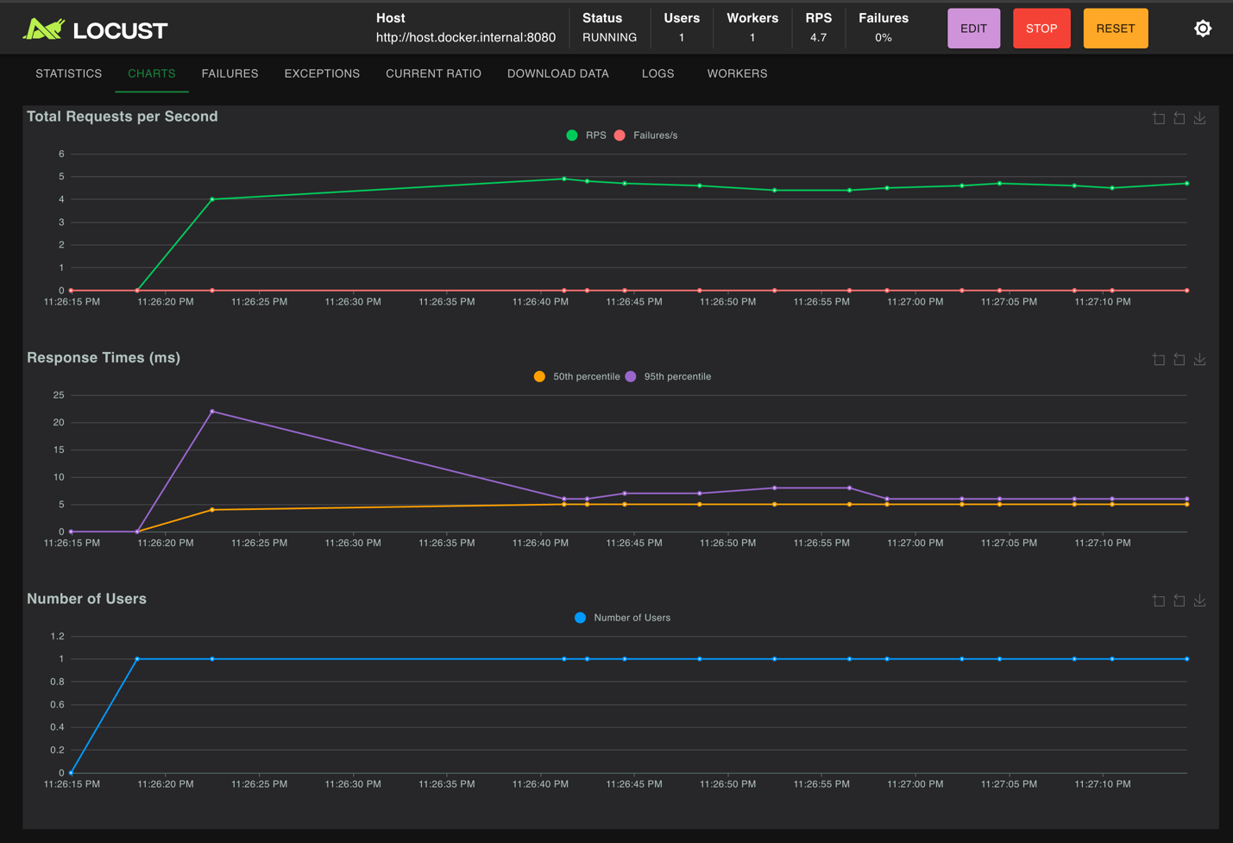
Tradeoffs: Common Operations and Data Structure Choice
In real-world systems, read operations are usually much more common than write operations. For example, users frequently fetch data such as product lists or records, while updates or inserts happen less often. Because of this, systems are often designed to optimize for fast and scalable reads.
This access pattern directly affects the choice of data structures. When reads dominate, it is important to use data structures and synchronization mechanisms that allow efficient concurrent reads, such as using read-write locks or read-optimized maps. If a write-heavy structure or coarse-grained locking is used, frequent reads may be unnecessarily slowed down. Therefore, understanding whether a workload is read-heavy or write-heavy helps determine how data should be stored and protected in memory.
GET vs POST Statistics: What Is Happening?
After running both GET and POST requests with no failures, clear differences appear in their statistics.
GET requests generally show higher throughput and more stable response times, while POST requests tend to have slightly lower throughput and higher tail latency. This happens because GET requests are read-only and usually involve minimal processing. In contrast, POST requests require additional work such as parsing request bodies, acquiring exclusive locks, and modifying shared data structures.
As a result, POST requests introduce more overhead and variability, which becomes visible in higher p95 and p99 latency values. These differences highlight why percentiles are more useful than averages when evaluating performance, since they better capture the cost of slower operations.
2. Local Test
Screenshot
(1) Run 1 worker + 50 users + 10 users/sec ramp-up + GET:POST = 3:1
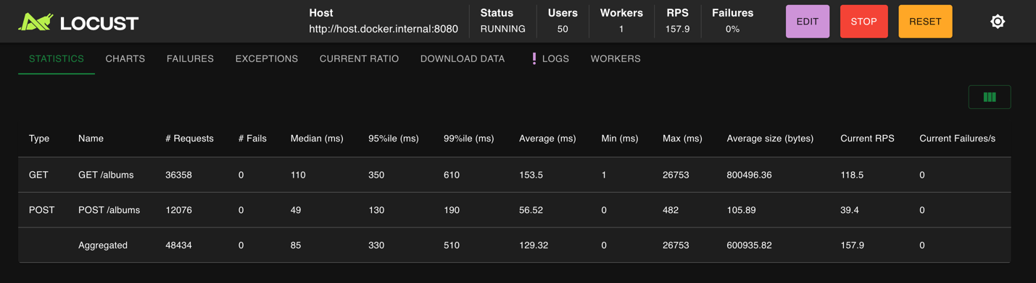
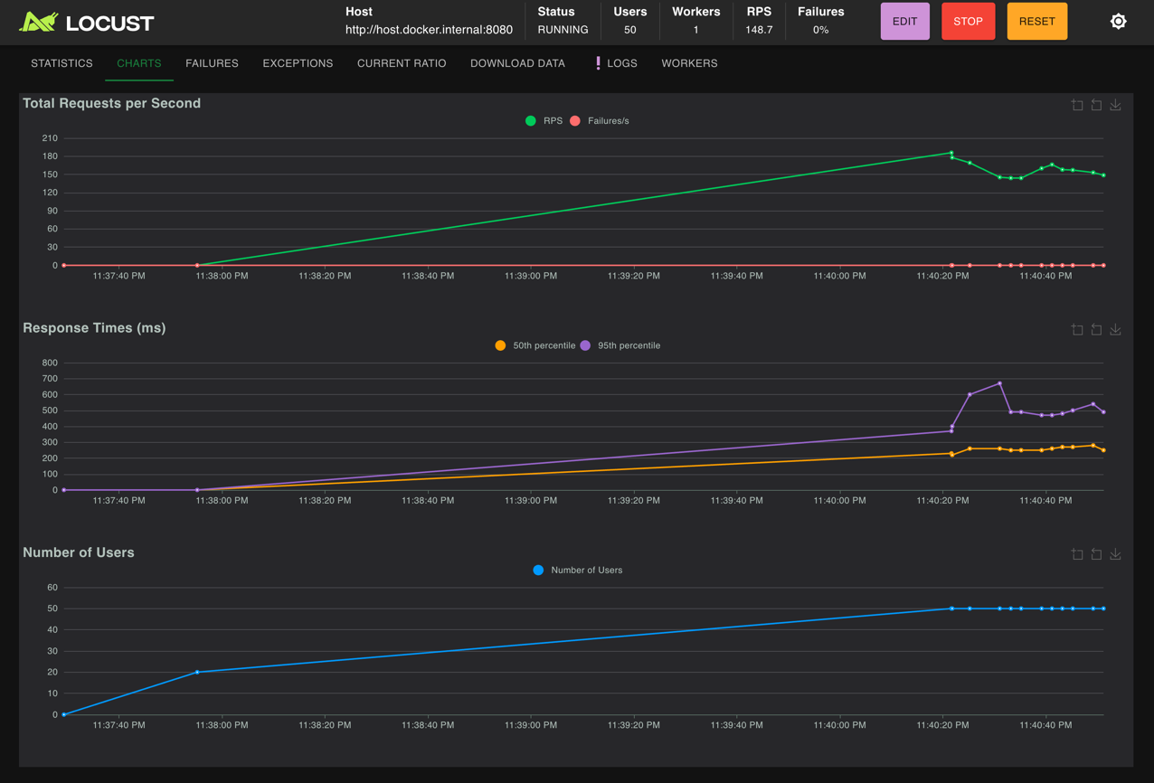
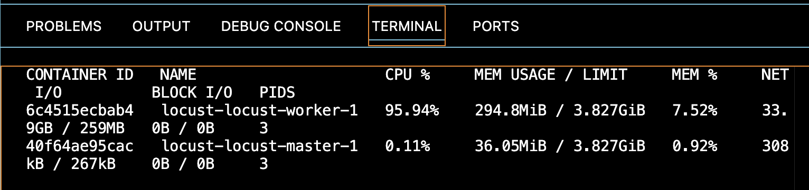

2. Amdahl’s Law

（1） Worker: GET vs POST Statistics and Whether They Make Sense
With 1 Locust worker, my results showed:
GET /albums:
Current RPS ≈ 118.5
Average latency ≈ 153 ms
Response size ≈ ~800 KB (very large)
Tail latency is high (p95 ≈ 350 ms, p99 ≈ 610 ms, max extremely large)
POST /albums:
Current RPS ≈ 39.4
Average latency ≈ 56.5 ms
Response size ≈ ~106 bytes (very small)
Tail latency is much smaller (p95 ≈ 130 ms, p99 ≈ 190 ms)
These throughputs do make sense given the workload:
GET returns a large response and becomes more expensive as the album list grows.
POST is small, but it performs a write (JSON parse + append), which still adds overhead.
The total observed throughput (aggregate RPS ≈ ~158) is reasonable for a single load generator process, but I also observed the Locust worker CPU near 100%, meaning the load generator itself becomes a bottleneck before the server necessarily fails.
So in this case, throughput is not only limited by the server, but also by the single Locust worker’s CPU capacity.
(2) Result of 4 workers
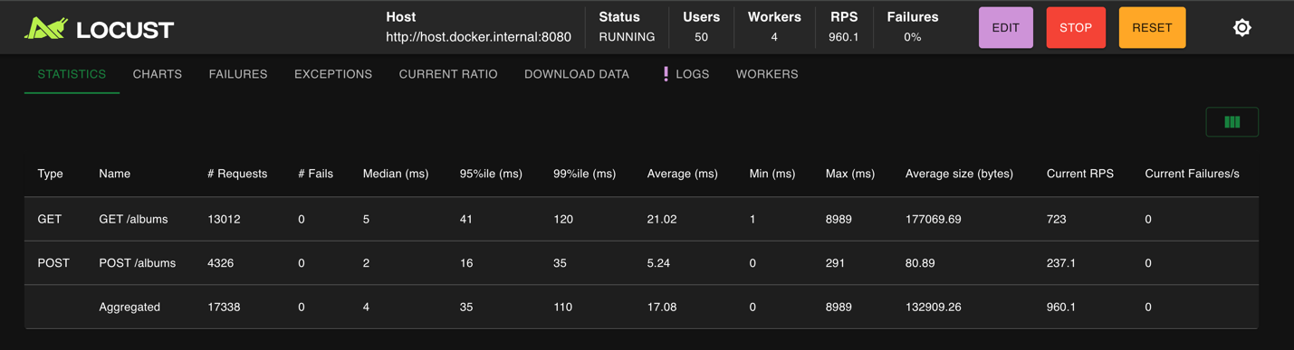
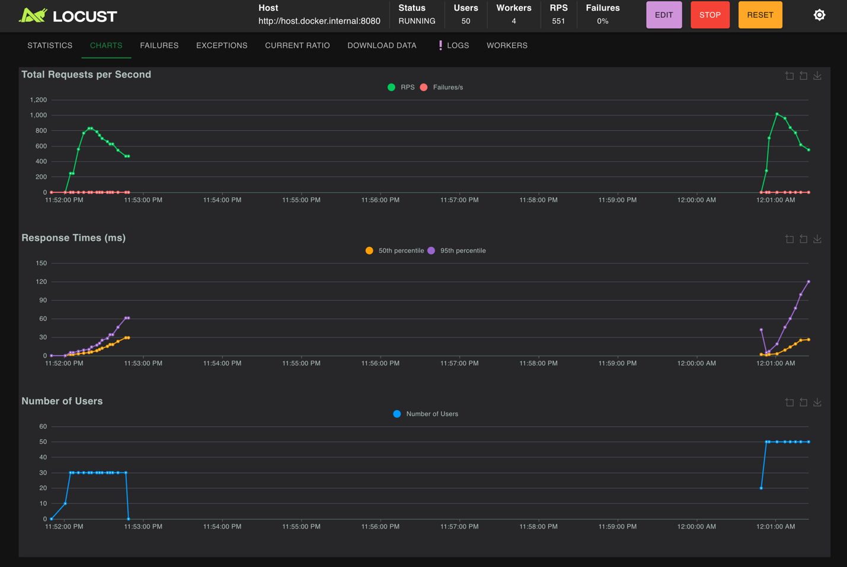
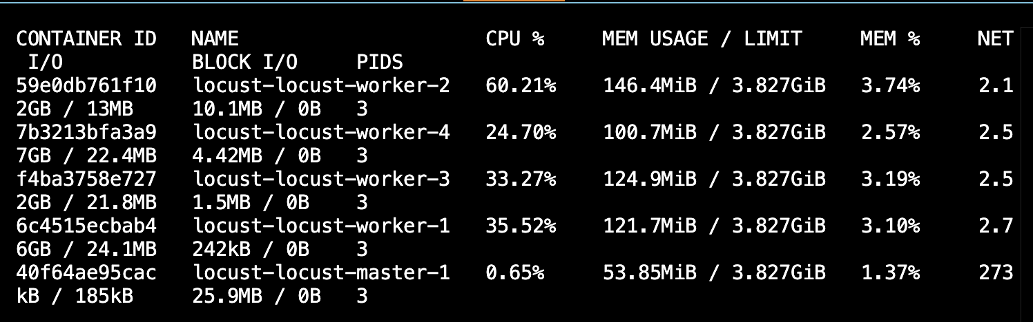
Scaling Workers to 4: Does Throughput Scale Linearly?
After increasing the worker count from 1 → 4, total throughput increased significantly:
Aggregate RPS increased by ~6×, not exactly 4×.
CPU usage was distributed across workers rather than maxing out a single one.
Latency (especially p95) increased under higher load.
This shows that throughput does not scale linearly, which aligns with Amdahl’s Law.
Is there any way in which the reading and writing of the same item to something like a hashmap might contribute to your observations?
Yes. Accessing the same hashmap for both reads and writes can affect performance, and this helps explain the results we observed.
When multiple workers try to write to the same hashmap, those write operations cannot run fully in parallel and must be synchronized. This creates contention and causes some requests to wait, which limits how much throughput can increase as more workers are added. Even though GET requests are read-only, they can still be slowed down when writes are happening at the same time.
Because of this shared data access, adding more workers does not lead to linear performance improvement, which matches what Amdahl’s Law predicts. The serial part of the workload (writes to the hashmap) becomes the bottleneck.
3. Context Switching
Screenshort
(1) run with FastHttpUser
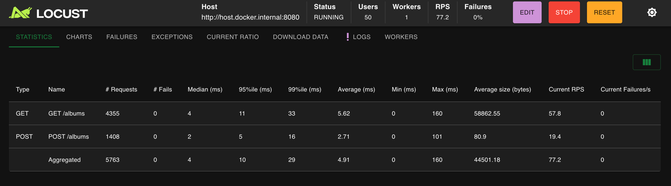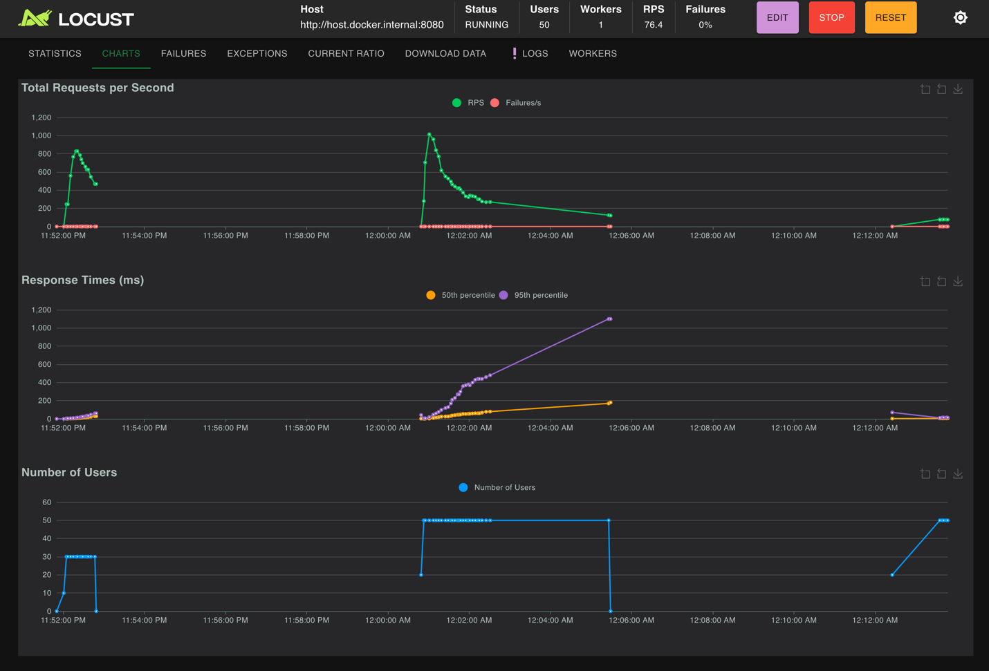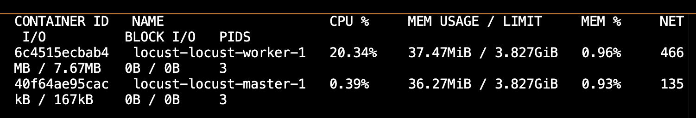
Observations After Switching to FastHttpUser
After replacing HttpUser with FastHttpUser and running the same load test (GET:POST = 3:1, 50 users, 1 worker), I observed the following:
Overall throughput (RPS) stayed around ~75–80 RPS
Response times were low and stable
GET average latency ≈ 5–6 ms
POST average latency ≈ 2–3 ms
No failures occurred
Locust worker CPU usage dropped significantly
From previously near 100% CPU down to about 20% CPU for the worker container
This shows that the load generator itself was no longer the bottleneck.
Why This Happened
The key difference is how requests are generated:
HttpUser uses python-requests, which is implemented mostly in Python and becomes CPU-bound at high concurrency.
FastHttpUser uses geventhttpclient, which relies on C-based HTTP parsing and is much more efficient.
As a result:
Each request requires less CPU work
The Locust worker can generate the same load using much less CPU
Context switching and Python overhead on the load generator are reduced

